21. **HALF ADDER**  
**EXP.NO: 21**  
**AIM:**To design and implement the two bit half adder using Logisim simulator.

**PROCEDURE:**  
1)      Pick and place the necessary gates.  
2)      Insert 2 inputs into the canvas.  
3)      Connect the inputs to the XOR gate and AND gate.  
4)      Insert 2 outputs into the canvas.  
5)      Make the connections using the connecting wires.  
6)      Verify the truth table.   
  
**TRUTH TABLE:**  
  
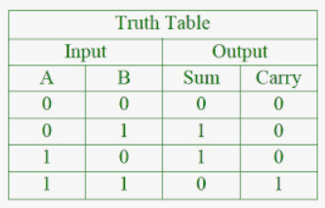  
  
S = A XOR B        C = A AND B

Logical Diagram:

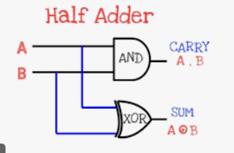

Half Adder using NAND Gates:

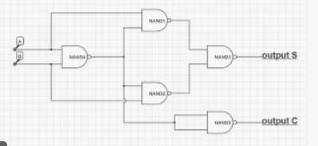

Half Adder using NOR Gates:

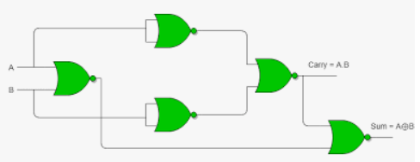

**OUTPUT**  
  
  
  
  
  
  
  
  
  
  
  
  
  
**RESULT:**Thus 2-bit half adder has been designed and implemented successfully using logisim simulator.

22. **TWO BIT HALF SUBTRACTOR**  
**EXP.NO: 22**  
**AIM:**To design and implement the two bit half subtractor using Logisim simulator.   
**PROCEDURE:**  
1)      Pick and place the necessary gates.  
2)      Insert 2 inputs into the canvas.  
3)      Connect the inputs to the OR gate, AND gate and NOT gate.  
4)      Insert 2 outputs into the canvas.  
5)      Make the connections using the connecting wires.   
6)      Verify the truth table.   
**TRUTH TABLE:**

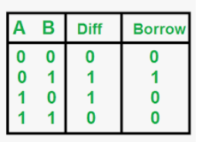  
  
Diff=A'B+AB'  
  
Borrow = A'B

Logical Diagram:

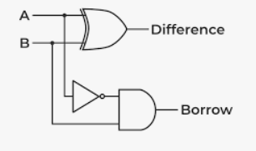

Half Subtractor using NAND Gates:

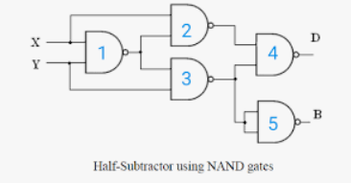

Half Subtractor using NOR Gates:

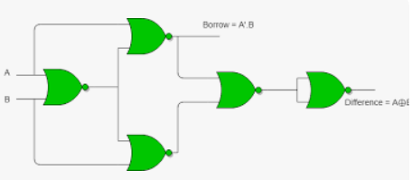  
  
**OUTPUT**  
  
  
  
  
  
  
  
   
  
  
  
**RESULT:**Thus 2-bit half subtractor has been designed and implemented successfully using logisim simulator.

23. **FULL ADDER**  
**EXP.NO: 23**  
**AIM:**To design and implement the full adder using Logisim simulator.  
**PROCEDURE:**  
1)      Pick and place the necessary gates.  
2)      Insert 3 inputs into the canvas.   
3)      Connect the inputs to the XOR gate, AND gate and OR gate.  
4)      Insert 2 outputs into the canvas.   
5)      Make the connections using the connecting wires.  
6)      Verify the truth table.   
**TRUTH TABLE:**  
  
  
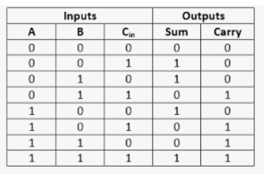  
Sum=(A⊕B) ⊕Cin  
  
Carry=A.B+ (A ⊕B)

Logical Diagram:

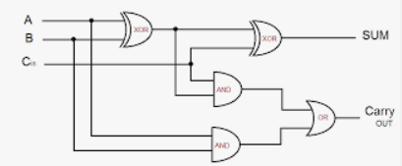

Full adder using NAND Gates:

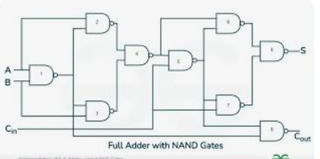

Full adder using NOR Gates:

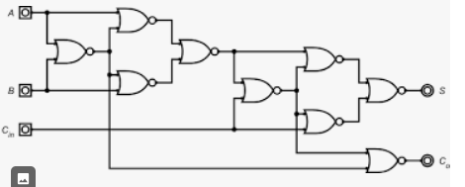

**OUTPUT**  
  
  
  
  
  
  
  
  
  
  
  
  
  
  
**RESULT:**Thus full adder has been designed and implemented successfully using logisim simulator.

24. **FULL SUBTRACTOR**  
**EXP.NO: 24**  
**AIM:**To design and implement the full subtractor using Logisim simulator.   
**PROCEDURE:**  
1)      Pick and place the necessary gates.   
2)      Insert 3 inputs into the canvas.   
3)      Connect the inputs to the XOR gate, AND gate and OR gate.  
4)      Insert 2 outputs into the canvas.  
5)      Make the connections using the connecting wires.  
6)      Verify the truth table.  
**TRUTH TABLE:**  
  
  
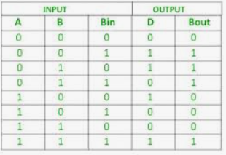  
Diff=(A ⊕ B) ⊕ 'Borrowin'  
  
Borrow=A'.B + (A ⊕ B)'

Logic Diagram:

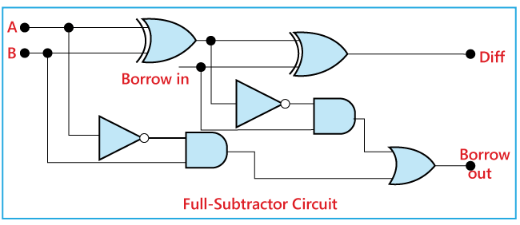

Full Subtractor using NAND Gates:

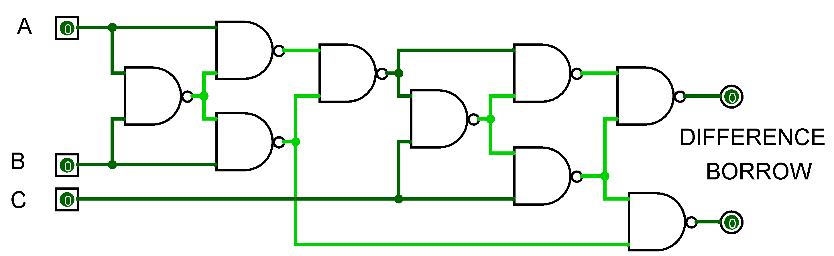

Full Subtractor using NOR Gates:

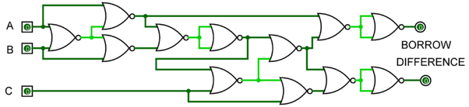

**OUTPUT**  
  
  
   
  
  
  
  
  
  
  
  
  
**RESULT:**Thus full subtractor has been designed and implemented successfully using logisim simulator.